Practical – Week2
- Develop a C program that uses the system calls open(), read(), write(), and close() to copy the contents of one file to another. Explain how control transitions between user space and kernel space during execution.
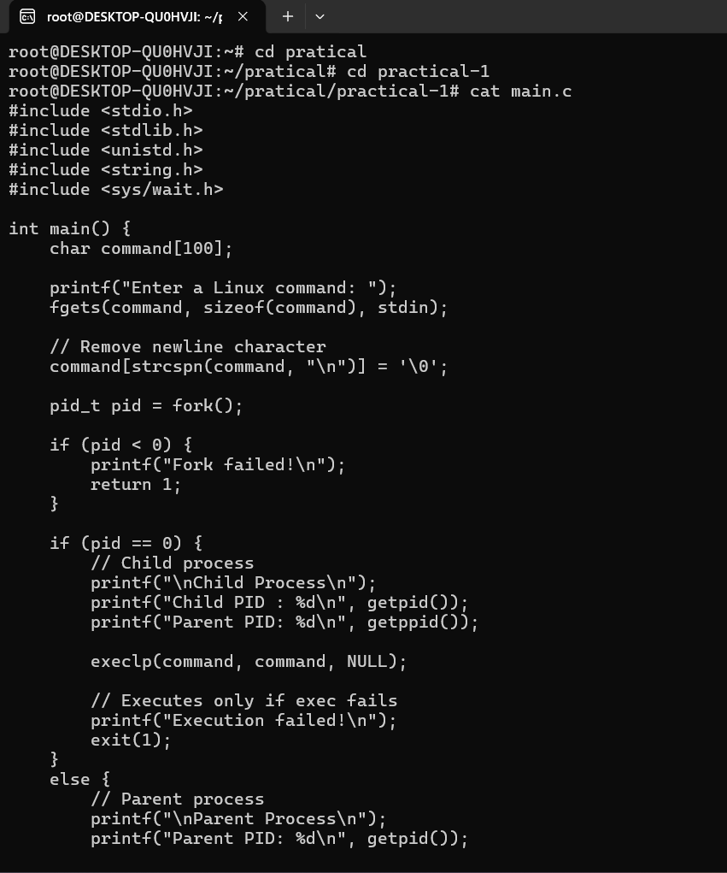

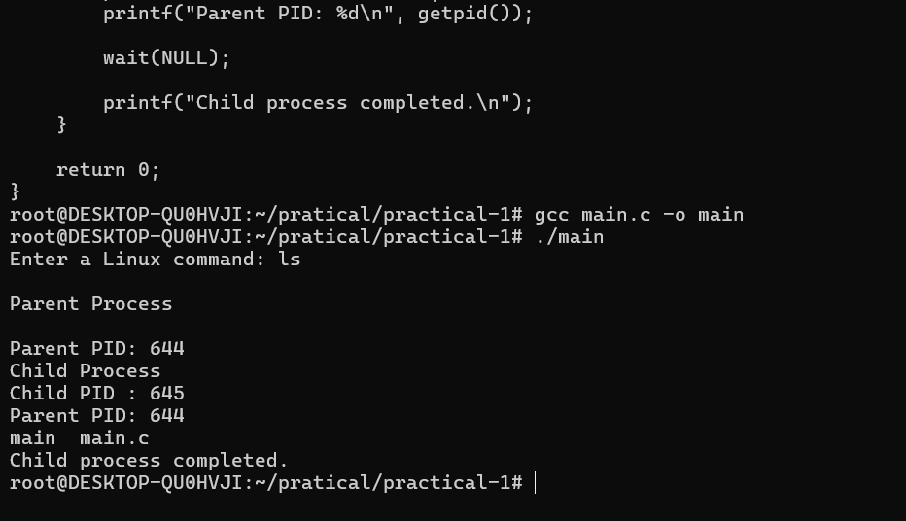
Report: I compiled and ran filecopy.c to copy source.txt to destination.txt. The program reported "File copied successfully," and cat destination.txt showed the content
matched the source exactly. ls -l confirmed both files were the same size (40 bytes), and diff source.txt destination.txt produced no output, indicating no differences. This confirms the program correctly reads from the source file and writes an identical copy
to the destination file.

- Use the strace utility to trace all system calls generated by the command cat sample.txt. Analyze the sequence of system calls and identify the kernel services involved

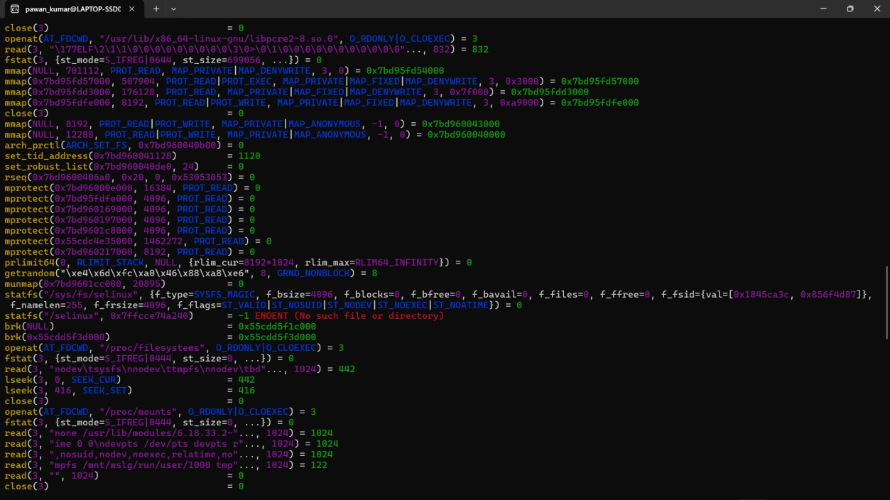
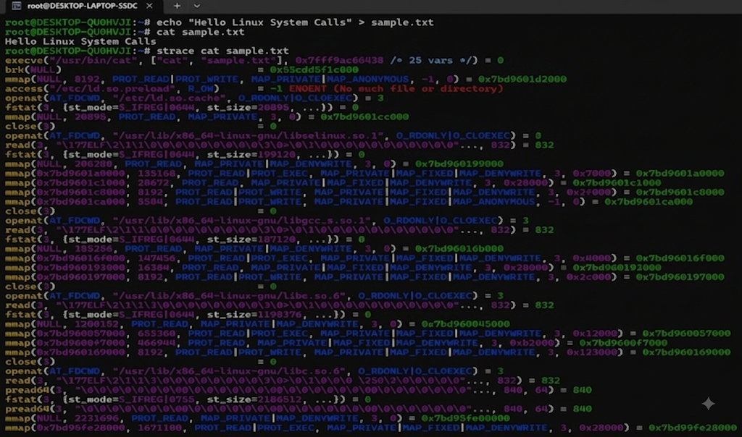

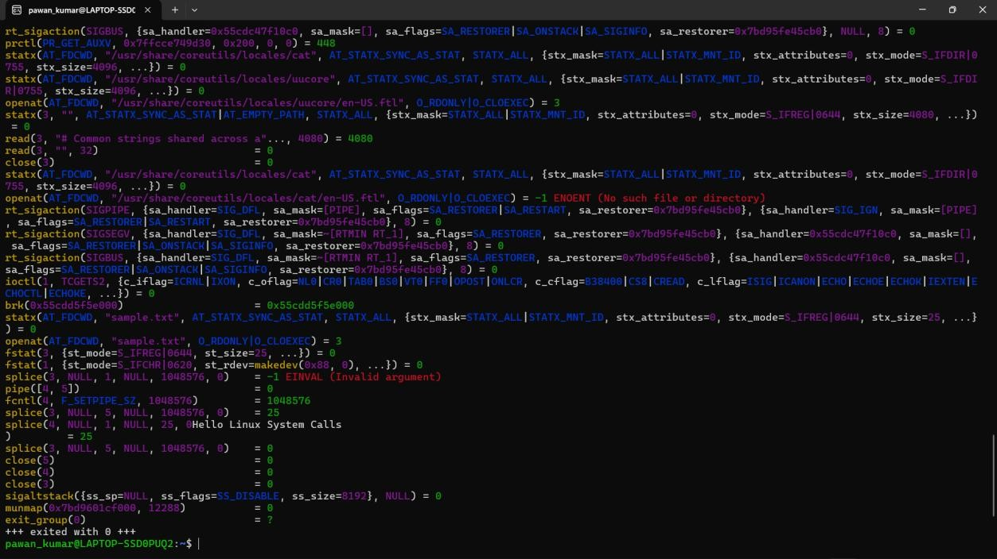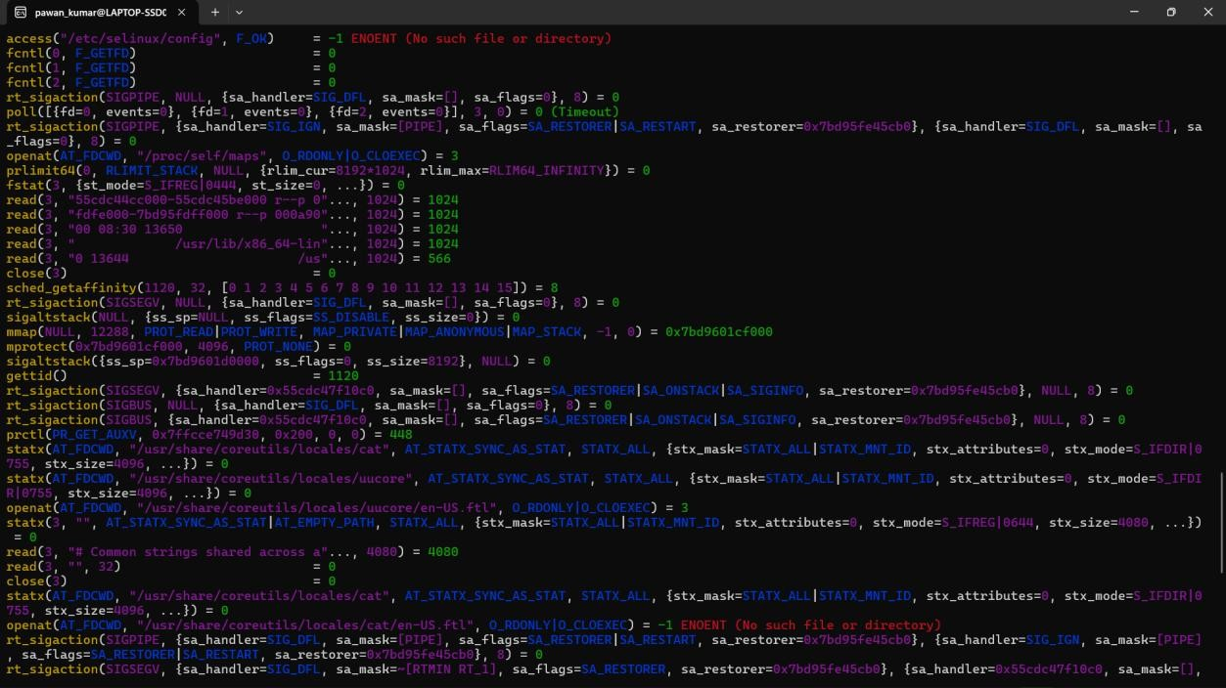

Report: I ran strace cat sample.txt. The trace showed openat() to open the file, fstat() for metadata, splice() to transfer data directly to stdout, and close() to release the
descriptor. This confirms cat uses efficient kernel calls like splice() rather than a plain read/write loop.

